1. Zombie Runner Game

2. To collect the bag of gold and to save the life of player from the zombies.

3. One day a boy went for the adventure and suddenly the whole world changed into the zombie world and the player have to survive in that zombie world.

4. 1 Playing Character - Jack The Adventures Boy

5. Zombie , Bags of Gold and Zombie Plants

6. 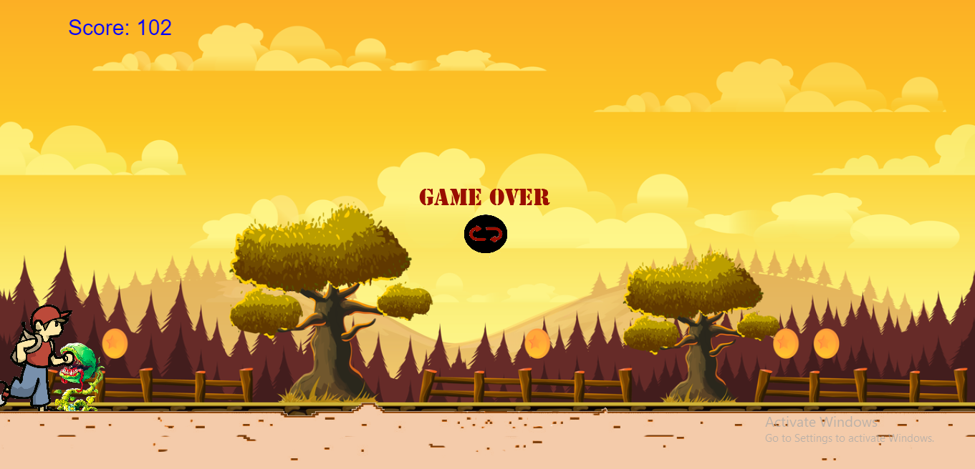

7.The player have to collect the coins and have to survive from the zombie and the zombie plants .The velocity (speed)of the player and the zombie plants increase as the game goes to the end.